2020 02 09 NR Daily Log





***DATE OF REPORT: NOC MANAGER 0700 – 1900:***

***NOC MANAGER 1900 – 0700:***

***DUTY CONTROLLER 0630 – 1830:***

***DUTY CONTROLLER 1830 – 0630:***

***SUPPORT CONTROLLER 0630 – 1830:***

***SUPPORT CONTROLLER 1830 – 0630:***

***LONDON CONTROLLER 0700 – 1900:***

***LONDON CONTROLLER 1900 – 0700:***

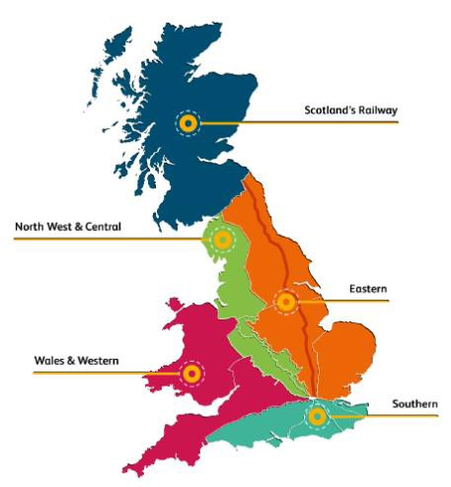

Sunday 09th February 2020 Lucinda Wing

Matthew Whitfield Bob Scoot

David Newton Peter Ure

Jo Billson Darren Griffen Keith Stokes

# TABLE OF CONTENTS

1. WRONG SIDE FAILURE REPORTS 3
2. SIGNALS PASSED AT RED (CATEGORY ‘A’) 3
3. DERAILMENTS 3
4. COLLISIONS 3
5. TRAIN OR VEHICLE RUNAWAY 3
6. OPERATIONAL INCIDENTS 3
7. TRAINS WITH STRANDED PASSENGERS 4
8. SIGNIFICANT POSSESSION PROBLEMS 4
9. FATALITIES 4
10. INJURIES/ASSAULTS 4
11. NEAR MISSES 4
12. RAILWAY CRIME 4
13. STATION OVERRUNS 5
14. BROKEN RAILS/TRACK DEFECTS 5
15. POWER FAILURES 5
16. POINTS FAILURES 5
17. SIGNALS/SIGNALLING SYSTEMS FAILURES 5
18. TRACK CIRCUIT & AXLE COUNTER FAILURES 5
19. BRIDGE STRIKES 5
20. ROAD VEHICLE INCURSIONS (NON-LEVEL CROSSINGS) 5
21. TRACTION FAILURES 5
22. WEATHER-RELATED PROBLEMS 6
23. FIRES 13
24. WILD REPORTS & HABD ACTIVATIONS 15
25. GROUP STANDARDS GE/RT8250 & GO/RT3350 15
26. TPWS 15
27. MISCELLANEOUS 15
28. REVIEW TABLE 16
29. REAL TIME PERFORMANCE FIGURES 17

None.

***01 WRONG SIDE FAILURE REPORTS***

***02 SIGNALS PASSED AT RED (CATEGORY ‘A’)***

None.

None.

***03 DERAILMENTS***

***04 COLLISIONS***

None.

***05 TRAIN OR VEHICLE RUNAWAY***

None.

***06 OPERATIONAL INCIDENTS***

### Southern (Sussex) – CCIL 2091189

At 0437 Brighton ECO advised that B261 electrical section at Tilgate Sidings had tripped. Tilgate Sidings were blocked as per KS WON 46, Item 130. Following initial investigation, it transpired that an RRV had come into contact with the 3rd rail, which should have been isolated if staff required to move on track machines. No injuries were reported, and the worksite was stood down. The ES and Machine Controller were relieved off duty for interview and ‘for cause’ screening. Three Bridges ECO subsequently isolated Tilgate Sidings whilst investigations were ongoing. The traction current was restored at 0738 after all personnel were clear of the Sidings and Marker Boards were in the correct position.

### Southern (Wessex) – CCIL 2091179/ Fault No. 463130

At 0430 a Road/Rail Vehicle (RRV) working within Route Business Wessex managed possession WON 46 item 152 (Barnes Junction – Feltham Junction, Down and Up Main/Richmond lines, Twickenham – Strawberry Hill, Down Strawberry Hill line, Strawberry Hill – St Margarets, Up Strawberry Hill/Up Passenger Loop line, 0120 Sat to 0420 Mon), ran through No. 608 points at Twickenham station. The Operations Delivery Manager was appointed as the investigating officer. Pway and S&T staff were sent to site. The Machine Operator, employed by BCM, was relieved of duty for interview and screening. At 0705 S&T reported that the only damage was to the rear stretcher which would be replaced within the possession.

***07 TRAINS WITH STRANDED PASSENGERS***

|  |  |  |  |  |  |
| --- | --- | --- | --- | --- | --- |
| ***Region / Route*** | ***Train*** | ***Since*** | ***Between*** | ***OUTCOME*** | ***CCIL*** |
| Southern / Kent | 2F14, Southeastern, 0704  Sevenoaks – London Charing Cross | 0716 -  0750 | Knockholt - Chelsfield | Obstruction on the line, removed by Mobile Operations Manager | 2091227 |
| W&W / Western | 1T46, Heathrow Express, 1040 London Paddington – Heathrow T5 | 1055 -  1415 | Paddington – Acton ML | OLE dewirement Main lines, assisting locomotive being arranged. Ole staff to reduce affected section | 2091428 |
| W&W / Western | 2T47, TfL Rail (Crossrail), 1042 London Paddington – Heathrow T5 | 1055 -  1402 | Paddington – Acton ML | OLE dewirement Main lines, assisting locomotive being arranged. Ole staff to reduce affected section | 2091428 |
| W&W / Western | 9P40, TfL Rail (Crossrail), 0955 Reading – London Paddington | 1055 -  1330 | Paddington – Acton ML | OLE dewirement Main lines, assisting locomotive being arranged. Ole staff to reduce affected section | 2091428 |
| W&W / Western | 2P37, Great Western Railway, Didcot Parkway – London Paddington | 1055 -  1330 | Paddington – Acton ML | OLE dewirement Main lines, assisting locomotive being arranged. Ole staff to reduce affected section | 2091428 |
| W&W / Western | 2E42, Great Western Railway, 1338 Bristol Temple Meads – Worcester Shrub Hill | 1410 -  1630 | Yate – Cam & Dursley | Tree on line removed. Delay occurred after two passenger’s had self evacuated | 2091637 |
| Southern/Kent | 2Y68, Southeastern, 1414  Faversham - Victoria | 1545-  1850 | Farningham Road - Swanley | Tree on line struck by 2Y68. Passenger evacuation complete at 1850 | 2091715 |

***08 SIGNIFICANT POSSESSION PROBLEMS***

None.

***09 FATALITIES***

None.

***10 INJURIES/ASSAULTS***

### Eastern (Anglia) – CCIL 2091133

At 0056 (Sun) it was advised that a member of Network Rail staff, Ipswich Delivery Unit en route to work at Ardleigh CCTV Level Crossing was suffering from seizure like symptoms. The member of staff was conveyed to hospital for assessment.

### Southern (Kent) – CCIL 2091160

At 0210 it was advised that a member of Keltbray staff working at Winchelsea had sustained an injury to their foot whilst renewing wheel timbers. The member of staff was conveyed to hospital for treatment.

***11 NEAR MISSES***

### Eastern (Anglia) – CCIL 2091345

At 0855 the driver of 2U27, Arriva Rail London, 0852 Enfield Town – London Liverpool Street, reported a near miss at Lincoln Road MCG LC, between Enfield Town and Bush Hill Park with a person on the crossing as the train approached, with the driver applying the emergency brake. The driver was fit to continue. The BTP (ref. 170) were advised.

***12 RAILWAY CRIME***

None.

***13 STATION OVERRUNS***

None.

***14 BROKEN RAILS/TRACK DEFECTS***

None.

***15 POWER FAILURES***

None.

***16 POINTS FAILURES***

None.

***17 SIGNALS/SIGNALLING SYSTEMS FAILURES***

### North West and Central (WCMLS) - CCIL 2091325 / Fault No. 881282

At 0900 the driver of 5Z18, Great Western Railway, 1010 St Phillips Marsh – Bath Spa, reported that RY1038 signal on the Up & Down Slow line at Northampton had reverted from a single yellow to red as the train approached. The driver was unable to stop and passed the signal at red by five metres. The reason for the reversion was track circuit ‘737’ momentarily failing. The driver was fit to continue.

|  |  |  |  |  |  |  |  |
| --- | --- | --- | --- | --- | --- | --- | --- |
| TRUST 763996 IQNA | | | | | | | |
| Cancelled | 2 | Part Cancelled | 0 | Trains Delayed | 3 | Minutes | 26 |

***18 TRACK CIRCUIT & AXLE COUNTER FAILURES***

None.

***19 BRIDGE STRIKES***

|  |  |  |  |  |  |  |  |
| --- | --- | --- | --- | --- | --- | --- | --- |
| ***Region / Route*** | ***Time*** | ***Location*** | ***Bridge No.*** | ***Dispensation*** | ***NWR*** | ***CCIL*** | ***TRUST*** |
|  |  |  |  |  |  |  |  |
|  |  |  |  |  |  |  |  |
|  |  |  |  |  |  |  |  |
|  |  |  |  |  |  |  |  |

***20 ROAD VEHICLE INCURSIONS (NON-LEVEL CROSSINGS)***

None

***21 TRACTION FAILURES***

None.

***22 WEATHER-RELATED PROBLEMS***

### North West and Central (WCMLS) - CCIL 2090455 / Fault No. 881119

With reference to an item detailed in this section of Thursday’s report regarding the land slip near Brandon Viaduct between Rugby and Coventry: Remedial work continued throughout the weekend, with the ESR eased over the Up Coventry line to 50 mph at 0506. All associated ESR equipment was confirmed as in place at 0646, with further remedial work still required to restore linespeed.

|  |  |  |  |  |  |  |  |
| --- | --- | --- | --- | --- | --- | --- | --- |
| TRUST 760099 IQR5 (since 07/02/20) | | | | | | | |
| Cancelled | 10 | Part Cancelled | 25 | Trains Delayed | 394 | Minutes | 3568 |

### Eastern (Anglia) – CCIL 2089809 & 2090765

As a result of Storm Ciara and resultant high wind speeds. A blanket speed restriction was imposed of 50 mph between 0800 (Sun) and 1900 (Sun) across the whole of the Anglia Route.

|  |  |  |  |  |  |  |  |
| --- | --- | --- | --- | --- | --- | --- | --- |
| TRUST 763711 XQHA | | | | | | | |
| Cancelled | 3 | Part Cancelled | 1 | Trains Delayed | 151 | Minutes | 1257 |

### Eastern (EM) – CCIL No CCIL raised.

As a result of Storm Ciara and resultant high wind speeds. A blanket speed restriction was imposed of 50mph between 1100 (Sun) and 1900 (Sun) across the East Midlands Route.

### Eastern (North & East & East Coast) – CCIL 2091813

As a result of Storm Ciara and resultant high wind speeds. A blanket speed restriction was imposed of 50 mph between 1100 (Sun) and 1900 (Sun) across the North & East and East Coast Routes.

|  |  |  |  |  |  |  |  |
| --- | --- | --- | --- | --- | --- | --- | --- |
| TRUST 763779 XQIA | | | | | | | |
| Cancelled | 0 | Part Cancelled | 0 | Trains Delayed | 6 | Minutes | 54 |

### North West and Central (WCMLS & Central) – CCIL No CCIL raised.

As a result of Storm Ciara and resultant high wind speeds. A blanket speed restriction was imposed of 50 mph between 0600 (Sun) and (2359) across the whole of the WCML South and Central Route. The blanket speed was lifted at 1810.

|  |  |  |  |  |  |  |  |
| --- | --- | --- | --- | --- | --- | --- | --- |
| TRUST 763787 XQEB | | | | | | | |
| Cancelled | 1 | Part Cancelled | 1 | Trains Delayed | 137 | Minutes | 1066 |
| TRUST 763778 XQNA | | | | | | | |
| Cancelled | 1 | Part Cancelled | 1 | Trains Delayed | 55 | Minutes | 692 |
| TRUST 763718 XQNA | | | | | | | |
| Cancelled | 2 | Part Cancelled | 1 | Trains Delayed | 84 | Minutes | 731 |
| TRUST 763788 XQEB | | | | | | | |
| Cancelled | 2 | Part Cancelled | 6 | Trains Delayed | 55 | Minutes | 887 |

### North West and Central (NW) – CCIL 2089985

As a result of Storm Ciara and resultant high wind speeds. A blanket speed restriction was imposed of 50 mph between 1000 (Sun) and 1900 (Sun) across the whole of the North West Route.

|  |  |  |  |  |  |  |  |
| --- | --- | --- | --- | --- | --- | --- | --- |
| TRUST 763660 XQFO | | | | | | | |
| Cancelled | 18 | Part Cancelled | 3 | Trains Delayed | 34 | Minutes | 508 |
| TRUST 764326 XQFM | | | | | | | |
| Cancelled | 0 | Part Cancelled | 1 | Trains Delayed | 58 | Minutes | 510 |
| TRUST 764316 XQFM | | | | | | | |
| Cancelled | 7 | Part Cancelled | 16 | Trains Delayed | 52 | Minutes | 524 |

### Southern (Kent) – No Generic CCIL created

As a result of Storm Ciara and resultant high wind speeds. A blanket speed restriction was imposed of 50 mph between 1000 (Sun) and 2359 (Sun) across the whole of the Kent Route, with the exception of HS1.

|  |  |  |  |  |  |  |  |
| --- | --- | --- | --- | --- | --- | --- | --- |
| TRUST 764090 XQMD | | | | | | | |
| Cancelled | 2 | Part Cancelled | 2 | Trains Delayed | 175 | Minutes | 2678 |

### Southern (Sussex) – CCIL 2089802

As a result of Storm Ciara and resultant high wind speeds. A blanket speed restriction was imposed of 50 mph between 1000 (Sun) and 2359 (Sun) across the majority of the Sussex Route.

|  |  |  |  |  |  |  |  |
| --- | --- | --- | --- | --- | --- | --- | --- |
| TRUST 763713 XQBV | | | | | | | |
| Cancelled | 2 | Part Cancelled | 17 | Trains Delayed | 296 | Minutes | 2035 |
| TRUST 763767 XQBV | | | | | | | |
| Cancelled | 9 | Part Cancelled | 1 | Trains Delayed | 111 | Minutes | 561 |

### Southern (Wessex) – CCIL 2089803

As a result of Storm Ciara and resultant high wind speeds. A blanket speed restriction was imposed of 50 mph between 0900 (Sun) and 1900 (Sun) across the whole of the Wessex Route.

|  |  |  |  |  |  |  |  |
| --- | --- | --- | --- | --- | --- | --- | --- |
| TRUST 763677 XQCW | | | | | | | |
| Cancelled | 7 | Part Cancelled | 21 | Trains Delayed | 171 | Minutes | 1459 |

### Wales and Western (Wales) – CCIL 2089612

As a result of Storm Ciara and resultant high wind speeds. A blanket speed restriction was imposed of 50 mph between 0600 (Sun) and 2359 (Sun) across the majority of the Wales Route.

|  |  |  |  |  |  |  |  |
| --- | --- | --- | --- | --- | --- | --- | --- |
| TRUST 763816 XQWS | | | | | | | |
| Cancelled | 2 | Part Cancelled | 1 | Trains Delayed | 67 | Minutes | 831 |

### Wales and Western (Western) – CCIL 2090118

As a result of Storm Ciara and resultant high wind speeds. A blanket speed restriction was imposed of 50 mph between 1200 (Sun) and 1800 (Sun) for the Thames Valley, between 1000 (Sun) and 2100 (Sun) for the West Country North & South between 0900 (Sun) and 0500 (Mon). The blanket speed was lifted for the Thames Valley at 1800. The blanket speed for West Country North & South was due to be removed at 0500 Monday morning.

|  |  |  |  |  |  |  |  |
| --- | --- | --- | --- | --- | --- | --- | --- |
| TRUST 764385 XQDZ | | | | | | | |
| Cancelled | 1 | Part Cancelled | 0 | Trains Delayed | 91 | Minutes | 734 |

### Eastern (Anglia) – CCIL 2091223 / Fault No. 304989

At 0710 the driver of 2C25, Govia Thameslink Railway, 0655 Cambridge – Letchworth Garden City, reported that they were at Shepreth due to plastic sheeting wrapped around the pantograph. The driver was able to lower the affected pantograph and secure it, going forward on half power at 0725. Following service were cautioned through the section, with further plastic identified lineside at Shepreth. The following service 2C29, Govia Thameslink Railway, 0755 Cambridge – London King’s Cross was cautioned, with the driver reporting that they had removed the plastic from site. Further advising that they plastic had probably blown onto the track from Shepreth Wildlife Park. Services were signalled normally from 0848.

|  |  |  |  |  |  |  |  |
| --- | --- | --- | --- | --- | --- | --- | --- |
| TRUST 763804 VETB | | | | | | | |
| Cancelled | 3 | Part Cancelled | 7 | Trains Delayed | 49 | Minutes | 897 |

### Southern (Wessex) – CCIL 2091264 / Fault No. 463145

At 0804 the driver of 2G16, South Western Railway, 0750 Guildford – Surbiton formed by units 455852, 455905 & 456023, reported striking a tree branch between Clandon and Horsley on the Up Cobham line. Concurrently the driver of 2G09, South Western Railway, 0716 Wimbledon – Surbiton formed by units 455917, 455871 & 456017, reporting making an emergency brake application and striking a tree on the Down Cobham line at Horsley. 2G16 was authorised forward at 0835, after the driver confirmed the units fit to proceed and that they had removed branches. The driver of 2G09 advised that the front fibreglass panel on the leading unit was damaged, and that there was a banging noise coming from the units when moved. In response, 2G09 was authorised forward at 35 mph, arriving at Guildford at 0906, 59 minutes late. Subsequent services were cautioned through the section, with services signalled normally at 0912, after confirmation that both lines were clear of obstructions.

|  |  |  |  |  |  |  |  |
| --- | --- | --- | --- | --- | --- | --- | --- |
| TRUST 763911 IQCX | | | | | | | |
| Cancelled | 2 | Part Cancelled | 4 | Trains Delayed | 53 | Minutes | 951 |

### Eastern (Anglia) – CCIL 2091272 / Fault No. 304991

At 0824 the driver of 6T62, GB Railfreight, 0625 Billericay – Whitemoor, reported a tree in contact with the OLE on the Down Cambridge line at Elsenham which appeared to be on fire. The following service was utilised to examine the line from the adjacent Up Cambridge line, with the driver reporting at 0829 that the fire was out, but there were two trees foul of the Down Cambridge line. In response the line was blocked between Audley End and Elsenham. CrossCountry services were terminated/started from Cambridge, with Greater Anglia implementing a shuttle service between Cambridge and Audley End. The Cambridge – Stansted Airport shuttle was cancelled. The Cambridge Mobile Operations Manager, OLE and Off-track staff were on site from 0854. At 0926 OLE staff advised that the Catenary Wire was stranded between stanchions C59/35 and C59/37. An isolation was effected at 1057 to allow repair work to be carried out, but the commencement of said repairs was delayed due to high wind speeds. It was not possible to run a diesel service due to the possibility of further damage being caused, with one tree resting on the Catenary Wire which was hanging by a single strand. A repair plan was formulated to effect repairs overnight between 0000 (Mon) and 0330 (Mon).

|  |  |  |  |  |  |  |  |
| --- | --- | --- | --- | --- | --- | --- | --- |
| TRUST 763865 XQHM | | | | | | | |
| Cancelled | 4 | Part Cancelled | 2 | Trains Delayed | 3 | Minutes | 63 |

### Wales and Western (Western) – CCIL 2091428/ Fault No. 459842

At 1029 following a tripping of OLE section 4808 on the Down Main line between Acton Main Line and Acton West, which would not reset, a tree was confirmed to have fallen onto the Down Main line and was partially obstructing the Up Main line. All services were diverted to the Relief lines with staff sent to site. At 1055 the traction current on lines was switched off after the OLE was reported to be hanging with one metre of the running rails on the Down Main line. Additional staff were sent to site. There were four trapped trains within the affected area with regular contact maintained with the train crews. BT Police were advised, ref 228. OLE staff attended to reduce the affected area. The power was restored to the Relief lines at 1320, allowing the trapped trains to be recovered. The tree was removed by 1810 with the Down Main line remaining Blocked to Electric Traction (BTET). Due to the high wind speeds repairs were unable to be undertaken until the wind speed dropped below 28mph. Two six hour possessions are planned for tonight and Monday night to complete repairs. The Down Main line will remain BTET throughout Monday with service levels reduced.

|  |  |  |  |  |  |  |  |
| --- | --- | --- | --- | --- | --- | --- | --- |
| TRUST 764224 XQDZ | | | | | | | |
| Cancelled | 189 | Part Cancelled | 30 | Trains Delayed | 96 | Minutes | 2514 |

***22 WEATHER-RELATED PROBLEMS (CONT.)***

### Scotland – CCIL 2091462 / Fault No. 349315

At 1102 the Shift Signalling Manager at Edinburgh IECC advised that ‘727’ track circuit on the Down E&G line between Winchburgh Junction and Linlithgow. 1R71, ScotRail, 1030 Edinburgh Waverley – Glasgow Queen Street was utilised to examine the line, reporting flooding at Overbridge 30. There was no effect on train running as the water was only up to the foot of the rail. However, by 1200 multiple track circuits on both lines were reported, with services losing circa 40 minutes due to cautioning. Service revisions were imposed to ease congestion. Normal working was resumed at 2024 after the three train rule was applied.

|  |  |  |  |  |  |  |  |
| --- | --- | --- | --- | --- | --- | --- | --- |
| TRUST 764139 XQLF | | | | | | | |
| Cancelled | 17 | Part Cancelled | 5 | Trains Delayed | 86 | Minutes | 1254 |

### North West and Central (NW) – CCIL 2091510. Fault No. 881334

At 1152 reports were received that both the Up & Down lines at Stainforth Tunnel had been submerged by moving floodwater with train running between Settle and Carlisle then suspended. After examination by P’Way staff at 1418 the line remained blocked for the remainder of the day. An inspection is due to take place on Monday morning.

### North West and Central (NW) – CCIL 2091566 / Fault No. 881361

At 1246 the driver of 1A22, Avanti West Coast, 1147 Liverpool Lime Street – London Euston advised they had an ADD activation on approach to CY122 signal on the Up Fast line between Winsford and Crewe. After inspecting the train, the driver reported that 8-10 droppers had come off and the OLE contact wire was in the four foot of the Up Fast line. A Mobile Operations Manager was sent to site. 9G52, Avanti West Coast, 1117 Preston – Birmingham New Street was trapped in rear. Arrangements were made to bring a rescue unit to site from Warrington Bank Quay to evacuate all passengers. At 1415 the Mobile Operations Manager confirmed the OLE had become detached from the droppers and that no other lines were affected. Passengers had been evacuated to the adjacent rescue train by 1500 (see section 07 of this Report). At 1509 it was confirmed that thirty droppers, five registration arms and a full jumper assembly required replacing. In addition, there were five kinks in the contact wire that required attention, with approximately eight hours of repair work required and a four-line possession. At 0021, the possession had been taken with works on going at the close of this report.

|  |  |  |  |  |  |  |  |
| --- | --- | --- | --- | --- | --- | --- | --- |
| TRUST 764600 IQFK | | | | | | | |
| Cancelled | 25 | Part Cancelled | 6 | Trains Delayed | 8 | Minutes | 490 |

### North West and Central (NW) – CCIL 2090874 / Fault No. 881362

At 1308 Rugby ECR reported the breakers out on OLE sections LQ7 & LQ8 complete, and that they were unable to feed OLE sections LQ9 & LQ10 complete affecting the Up and Down Penkridge line between Wolverhampton and Stafford. OLE and P’Way staff were sent to site. 1C64, West Midlands Trains, 1112 Crewe – Birmingham International was trapped at Penkridge. At 1425 it was advised that a tree was on the OLE at 20m 708 yards between Four Ashes and Penkridge. Nine further trees were reported as down, which in turn had parted the Return Conductor. Alternative feeding was carried out by 1545 for OLE sections LQ9 & LQ10 which returned the power between Penkridge and Stafford, thus allowing 1C64 to be returned to Stafford. By 1700 following alternative feeding arrangements power was restored at Wolverhampton, with the route between Wolverhampton and Stafford remaining blocked and remedial works commenced. Work was suspended at 1820 due to high wind speeds. By 2222 an emergency possession had been taken and all trees that were foul of the line removed. Repair works were on going at the close of this report.

|  |  |  |  |  |  |  |  |
| --- | --- | --- | --- | --- | --- | --- | --- |
| TRUST 764561 XQEB | | | | | | | |
| Cancelled | 49 | Part Cancelled | 29 | Trains Delayed | 63 | Minutes | 2158 |

***22 WEATHER-RELATED PROBLEMS (CONT.)***

### Wales and Western (Wales) – CCIL 2091611 / Fault No. 459883

At 1347, P’Way reported that there was storm damage had been located on the Single line between Llanaber and Talybont whereby large amounts of ballast and rocks were located within the four foot at 102m 40ch. foot full of ballast and large rocks. As a result, the line was blocked and to remain blocked for seven days pending a full assessment.

### North West and Central (NW) – CCIL 2091631

At 1403 it was reported that flood water from the river Caldew had resulted in the West Coast Main line being blocked between Carlisle and the Anglo Scottish boarder. Services were re-instated at 1648 following an inspection of the track and the river bridge. However, the line was blocked again at 2228 due to rising floodwater and track circuit 329 on the Down Main line and track circuit 323 on the Up Main line showing occupied. The route remained blocked as staff were unable to make an assessment. Works still on going at the close of this report.

|  |  |  |  |  |  |  |  |
| --- | --- | --- | --- | --- | --- | --- | --- |
| TRUST 764696 XQFO | | | | | | | |
| Cancelled | 4 | Part Cancelled | 3 | Trains Delayed | 3 | Minutes | 17 |

### Wales and Western (Western) – CCIL 2091637 / Fault No. 459861

At 1410 Off track staff blocked the Up and Down Charfield line between Standish Junction and Can & Dursley after the discovery of a large tree blocking both lines at Stonehouse Viaduct. A block to traffic was placed with the West Midlands Train Running Controller. Some services were diverted via Kemble and Swindon or terminated short of destination. The Down Charfield line was reopened at caution from 1502, after Off track staff had removed part of the obstruction. At 1600 the driver of 2E42, Great Western Railway, 1338 Bristol Temple Meads – Worcester Shrub Hill formed by units 158762 & 158747 that had been stood at Berkley Road Junction, reported that two passengers had egressed from the train. The BT Police (ref.

412) were advised. By 1625 Off track staff had removed the section of tree that was foul of the Up Charfield line and train running over the Up Charfield line was authorised. Normal signalling without restriction was authorised from 1643, after the driver of 2E42 had examined the line, reporting no signs of the egressed passengers. At 1954 Off track staff advised that they were leaving site, after the remainder of the tree had been cut down.

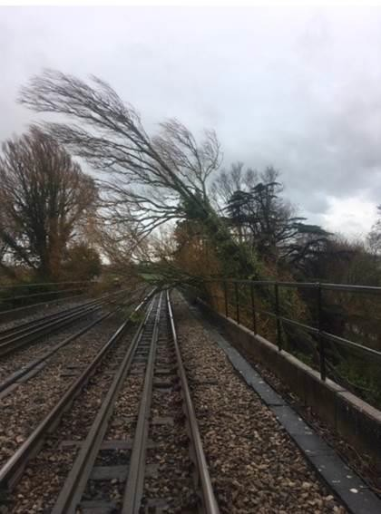

|  |  |  |  |  |  |  |  |
| --- | --- | --- | --- | --- | --- | --- | --- |
| TRUST 764721 XQDZ | | | | | | | |
| Cancelled | 0 | Part Cancelled | 2 | Trains Delayed | 32 | Minutes | 1085 |

***22 WEATHER-RELATED PROBLEMS (CONT.)***

### Southern (Kent) – CCIL 2091715/ Fault No. 463236

At 1545 the driver of 2Y68, Southeastern, 1414 Faversham – London Victoria, formed by unit 375825, reported that the train had struck a tree on the Up Chatham Main line, with the train having possibly ridden up over the tree. The Mobile Operations Manager and Emergency services were sent to site and at 1611 the Mobile Operations Manager confirmed the tree was blocking both lines but that the unit had not derailed, although the conductor rail had been dislodged by the impact. There were no reported injuries to passengers or staff. Arrangements were made for the 200 passengers on board to be evacuated onto a train brought alongside which was completed by 1850. A locomotive was sent to site to recover 2Y68 which was accomplished by 0325 with P’Way examining the line at the close of this report.

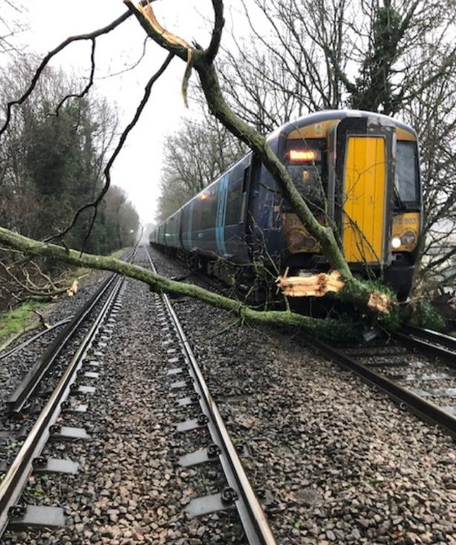

|  |  |  |  |  |  |  |  |
| --- | --- | --- | --- | --- | --- | --- | --- |
| TRUST 764742 XQMD | | | | | | | |
| Cancelled | 15 | Part Cancelled | 0 | Trains Delayed | 14 | Minutes | 142 |

### Southern (Kent) – CCIL 2091711

At 1616 platforms 1- 6 at London Victoria were blocked as a result of an issue with an unsecured ladder on the station roof. Contractors arrived on site but could not locate and secure the ladder until the weather conditions had subsided. London fire brigade and attended site and made a temporary repair to the ladder and contractors were deployed in order to ensure the ladder is safely in position ready for the start of service.

### Southern (Kent) – CCIL No CCIL raised

At 1600 it was reported that loose insulation panels on a building adjacent to the railway were presenting a risk to Lines/Platforms 1,2 & 3 at London Bridge. As such trains were cautioned and a watchman put in place.

***22 WEATHER-RELATED PROBLEMS (CONT.)***

### Eastern (North & East) – CCIL 2091755 / Fault No. 878127

At 1630, the Mobile Operations Manager reported that all lines were blocked at Kirkstall bridge due to flooding, with flood water 1inch above the rail head. Resulting in multiple axle counter and track circuit failures. Off track staff were on site at 2144 and were operating water pumps. OLE staff working in a pre- planned possession in Kirkstall with off track staff signed into the worksite to allow the use of additional pumps to be deployed.

### Southern (Sussex) – CCIL 2090495 / Fault No. 764542

At 1754 it was reported that the lead flashing on the lift shaft of platforms 5 & 6 at Gatwick had become loose. Rectification work required scaffolding to be erected which was unfeasible due to the high winds. As a result, platforms 5 & 6 were blocked and were expected to remain so throughout Monday. Services will be replatformed and some service alterations implemented.

|  |  |  |  |  |  |  |  |
| --- | --- | --- | --- | --- | --- | --- | --- |
| TRUST 764542 XQBV | | | | | | | |
| Cancelled | 0 | Part Cancelled | 0 | Trains Delayed | 14 | Minutes | 52 |

***23 FIRES***

None.

***24 WILD REPORTS & HABD ACTIVATIONS***

### Disconnected Hot Axle Box Detectors:

|  |  |  |  |  |  |  |  |  |  |
| --- | --- | --- | --- | --- | --- | --- | --- | --- | --- |
| *Region / Route* | *Location* | *Line* | *Date Disconnected* | *Reason* | *TOC’s/ FOC’s*  *advised* | *Planned Restoration Date* | *Date Restored* | *Function* | *Fault Number* |
| Eastern (Anglia) | Brentwood | Down Electric | 10/03/16 | Offline | Y | Awaiting update |  | IM | 234632 |
| Eastern (Anglia) | Brentwood | Down Main | 10/03/16 | Offline | Y | Awaiting update |  | IM | 234632 |
| Eastern | Margaretting | Up Main | 19/09/19 |  | Y | Awaiting update |  | IM | 298498 |
| Eastern (EM) | Chiltern Green | Down Slow | 11/07/19 | Defective | Y | Awaiting update |  |  | 148559 |
| Eastern (EM) | Napsbury | Up Fast | 11/07/19 | Defective | Y | Awaiting update |  |  | 148559 |
| Eastern (LNE) | Barkston | Up Main | 01/04/19 | Removed for P’Way work | Y | Awaiting update |  |  |  |
| NW & Central (NW) | Bolton-le- Sands | Up Main | 25/08/19 | Integrity Fault | Y | Awaiting update |  |  | 863361 |
| NW & Central (NW) | Hest Bank | Up Main | 25/08/19 | Integrity Fault | Y | Awaiting update |  |  | 863360 |
| NW & Central (NW) | Low Mill | Down Main | 26/11/14 | Awaiting replacement | Y | Awaiting update |  | IP | 671852 |
| NW & Central (NW) | Sutton Weaver | Down Main |  |  | Y | Awaiting update |  |  |  |
| NW & Central (WCMLS) | Bradnocks Marsh (Coventry) | Up Main | 29/12/19 | Integrity | Y | Awaiting Update |  |  | 872142 |
| NW & Central (WCMLS) | Castlethorpe | Up Fast | 27/11/18 | Error code 6.0 | Y | Awaiting Update |  | IM | 832410 |
| NW & Central (WCMLS) | Harecastle | Up Main | 01/04/19 | Rail incorrectly drilled | Y | Awaiting Update |  |  |  |
| NW & Central (WCMLS) | Penkridge | Up Penkridge | 04/11/19 | Integrity | Y | Awaiting Update |  |  | 870982 |
| NW & Central (WCMLS) | Spetchley |  | 29/12/19 | Integrity | Y | Awaiting Update |  |  |  |
| Wales & Western (Wales) | Dainton | Down Main | 17/11/19 | Defective PC | Y | Awaiting Update |  | IM | 453850 |
| Wales & Western (Western) | Cogload | Down Main | 25/01/20 |  | Y |  |  |  | 458740 |
| Wales & Western (Western) | Treverrin | Down Main | 01/07/19 |  | Y | Awaiting Update |  |  | 443474 |
| Wales & Western (Western) | Twerton | Down Main | 19/11/19 |  | Y | Awaiting Update |  |  | 454030 |
| Wales & Western (Western) | Warminster | Up Salisbury | 22/01/20 | Defective | Y | Awaiting Update |  |  | 458111 |

***24 WILD REPORTS & HABD ACTIVATIONS (CONT.)***

**Disconnected Wheel Impact Load Detectors:**

|  |  |  |  |  |  |  |  |  |  |
| --- | --- | --- | --- | --- | --- | --- | --- | --- | --- |
| *Region / Route* | *Location* | *Line* | *Date Disconnected* | *Reason* | *TOC’s/ FOC’s*  *advised* | *Planned Restorati on Date* | *Date Restored* | *Function* | *Fault Number* |
| Eastern (LNE) | Sessay | Up Slow | 18/06/2019 | Calibration |  |  |  | IM |  |
| North West & Central (NW) | Heaton Chapel | Up Slow | 30/07/2019 | Calibration |  |  |  | IM |  |
| Southern (Kent) | Sevington | Down Main | 25/04/2018 | PC Failure |  |  |  | IM |  |
| Southern (Kent) | Sevington | Up Main | 09/08/2018 | PC Failure |  |  |  | IM |  |
| Southern (Kent) | Swanley | Up Slow | 02/04/2019 | Calibration |  |  |  | IM |  |
| Scotland | Howwood | Up | 20/01/2019 | HOBC |  |  |  | IM |  |
| Wales & Western (Western) | Urchfont | Up | 11/04/2019 | PC Failure |  |  |  | IM |  |
| Wales & Western (Western) | Urchfont | Down | 11/04/2019 | PC Failure |  |  |  | IM |  |

***25 GROUP STANDARDS GE/RT8250 & GO/RT3350***

None.

***26 TPWS***

|  |  |  |  |  |  |  |  |  |
| --- | --- | --- | --- | --- | --- | --- | --- | --- |
| ***Region*** | ***Route*** | ***Train*** | ***Signal/PSR/ Buffer Stop*** | ***Line/Platform*** | ***Location*** | ***Speed (reported)*** | ***Speed (set)*** | ***CCIL*** |
|  |  |  |  |  |  |  |  |  |
|  |  |  |  |  |  |  |  |  |
|  |  |  |  |  |  |  |  |  |
|  |  |  |  |  |  |  |  |  |

***27 MISCELLANEOUS***

### Eastern (East Coast) – CCIL 2091127

At 2351 (Sat) it was reported that a member of staff working within WON 46 item 274, Hessle & Chalk Lane LC CCTV, Down and Up Main lines blocked (0025 Sun – 0730 Sun) an LNE IMDM York managed possession had arrived at the work site as an RRV driver possibly under the influence of drink/drugs. The staff member in question was employed by Stobart Rail and contracted into the works by Storey Rail. As a result, the 20mph ESR remained in place over the defective Level Crossing and the possession was cancelled. The staff member was relieved of duty and ‘for cause’ screening was arranged by Stobart Rail.

***27 MISCELLANEOUS (CONT.)***

### Scotland – CCIL 2091166 / Fault No. 349282

At 0240, P’Way staff reported that they had identified a sink hole at the toe of 93A points on the Up Coatbridge line between Burnhouse and Mossend North Junction. Structures staff and earthworks engineers were requested to site. After consultation with the On-Call structures engineer, P’Way staff advised at 0314 that the Up Coatbridge line was to be closed between Burnhouse and Mossend North Junction, with the Down Coatbridge line signalled for bi-directional working. Earthworths engineers, along with AMCO staff, were on site at 0450 and confirmed a culvert, that AMCO staff had jet washed from another location off track earlier in the night, had collapsed. AMCO have arranged to take possession of the line to carry out remedial works on Sunday night, with a watchman in place throughout the day.

|  |  |  |  |  |  |  |  |
| --- | --- | --- | --- | --- | --- | --- | --- |
| TRUST 764219 CQLM | | | | | | | |
| Cancelled | 0 | Part Cancelled | 0 | Trains Delayed | 17 | Minutes | 83 |

***28 REVIEW TABLE***

|  |  |  |
| --- | --- | --- |
| ***INCIDENT*** | ***TODAY’S TOTAL*** | ***DAYS SINCE LAST INCIDENT*** |
| **PASSENGER ACCIDENTAL FATALITIES** | **0** | **432** |
| **RAILWAY WORKFORCE FATALITIES** | **0** | **58** |
| **SIGNALS PASSED AT RED (CATEGORY ‘A’)** | **0** | **1** |
| **SIGNALS PASSED AT DANGER (ERROR/TECHNICAL SIGNAL REVERSION)** | **1** | **0** |
| **DERAILMENTS** | **0** | **2** |
| **TRAIN COLLISIONS** | **0** | **2** |
| **TRAINS STRIKING ROAD VEHICLES** | **0** | **13** |
| **ENVIRONMENTAL INCIDENTS** | **0** | **4** |

## OFFICIAL-SENSITIVE

15

Page 15 of 16

***29 REAL TIME PERFORMANCE FIGURES***

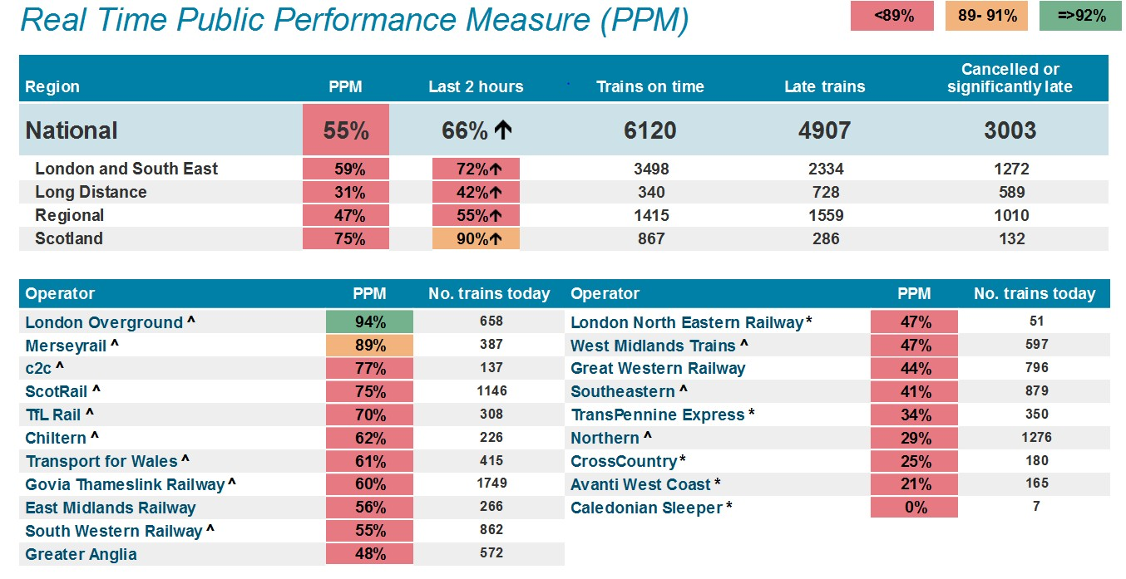

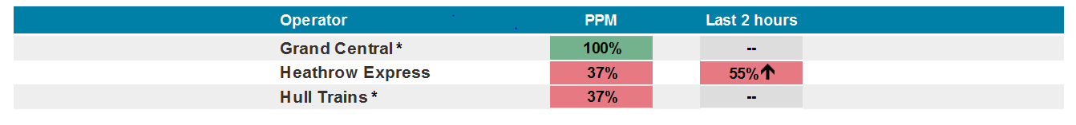

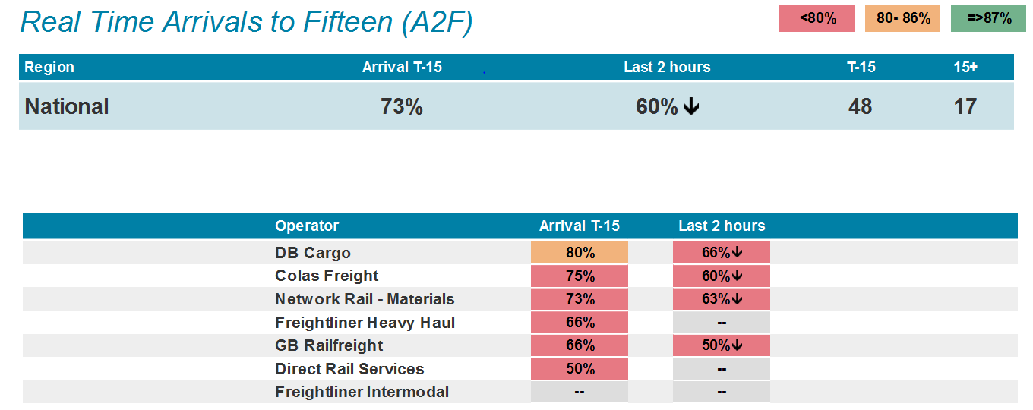

**OFFICIAL-SENSITIVE**

Page 16 of 16